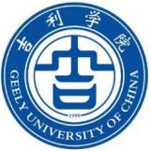
Graduation Certificate

This is certify that student, LIU Yuanli, female, born on May 17, 1999, studied in the English major of our university’s undergraduate program that upgraded from junior college from October 2020 to July 2022, has completed all the courses specified in the teaching plan and passed the examinations. She is allowed to graduate.
Principal : Que Haibao (signed) University: Geely University of China (sealed)
Certificate No.: 128021202205000864 | June 17, 2022

